LINEAR SEARCH WITHOUT RECURSION:

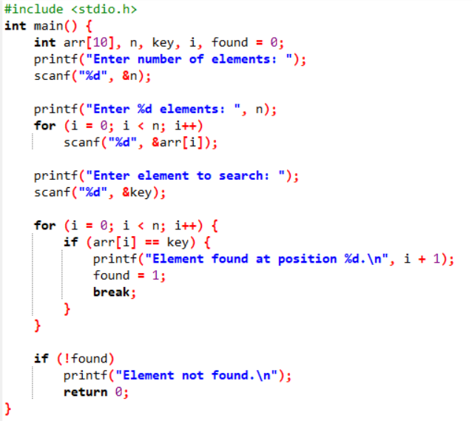

OUTPUT:

